15)Imports and exports
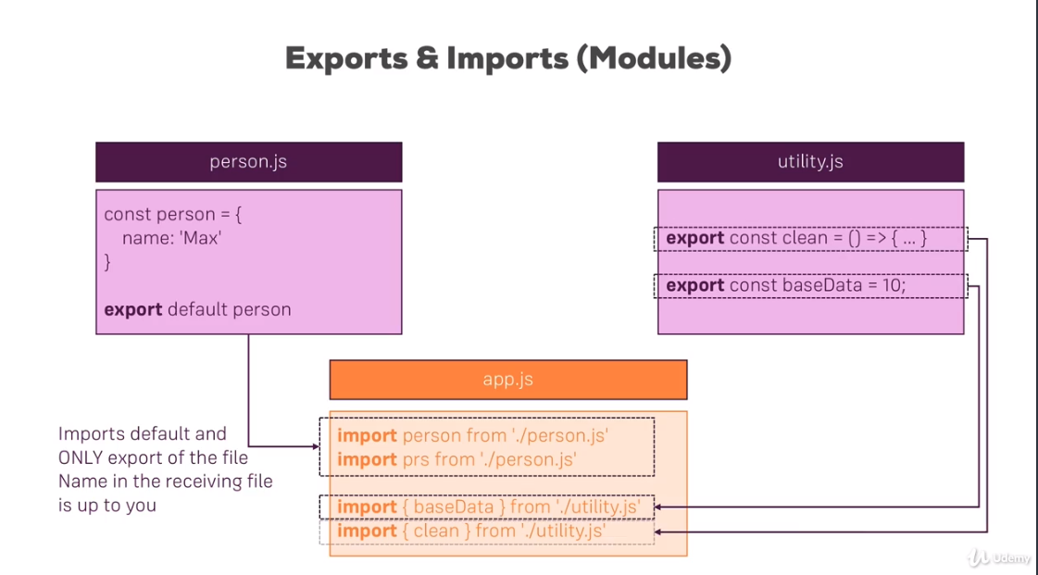
These are new import-export syntax avaliable in es6. Instead of 2 imports, we can also have one single import-
import {baseData, clean} from ‘./utility.js’
note that in first export w eused defualt so while importng we can use any name. This is what i have
shown my having 2 importing statements for first export.
it is a next gen havascript feature. It wnt run in browser(not vene in most modern browsers) like this. In next project we will setup project we will compile all these next gen js features into current gen javascript features.
Lets see variation of imports and exports
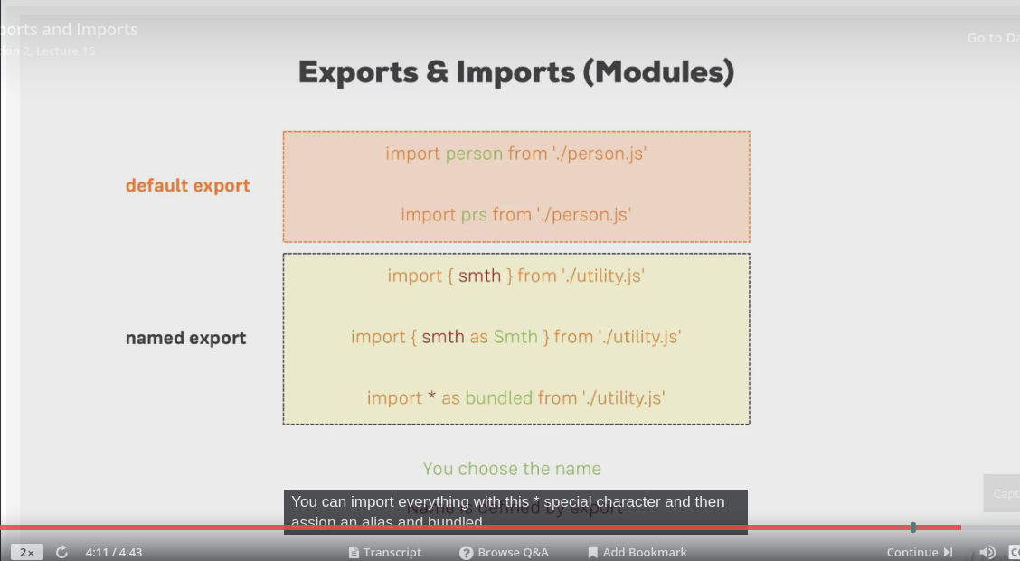
see named export section. In case of named section, names need to match.In second import , we are assigning alias to a named import. In third import we are importing everything that is exported in a file. Now bundeled will be js object which exposes what ever you export in other file as proeprties.
16)Undestanding the classes
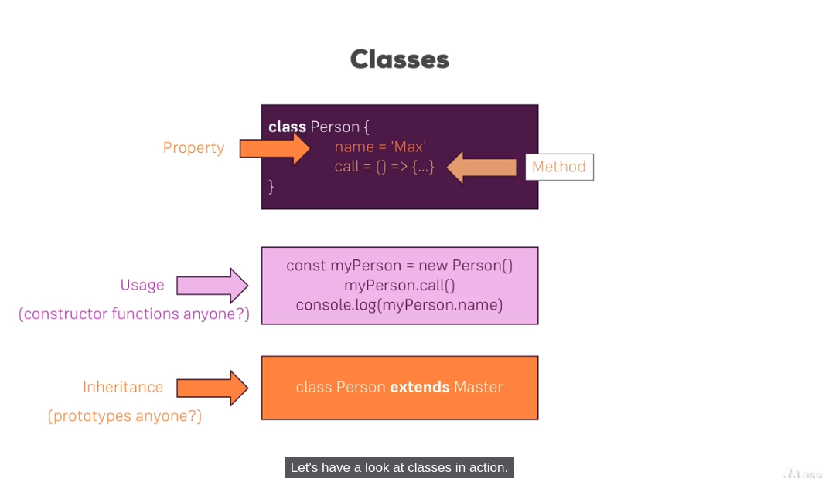
code-
class Human {
constructor() {
this.gender = 'male';
}
printGender() {
console.log(this.gender);
}
}
class Person extends Human {
constructor() {
super();
this.name = 'sumeet sood';
this.gender = 'female';
}
printMyName() {
console.log(this.name);
}
}
const person = new Person();
person.printMyName();
person.printGender();

here you can see how we create class variable inisde constructor. Then we do inheritance in class Person, but we call super in constrcutor of Person. By super we call constrcutor of parent class. This is mandatory, otherv w ewill get error.

We chnaged the value of gender in person class. So properties of super class are valaible in child class.
Classes are used by react to create components. Atleast it is one of 2 ways to create components in react.
Classes os cmpare to constrcutor fucntionand inheritance is comparable to prototypes.
17)Classes,proeprties and methods
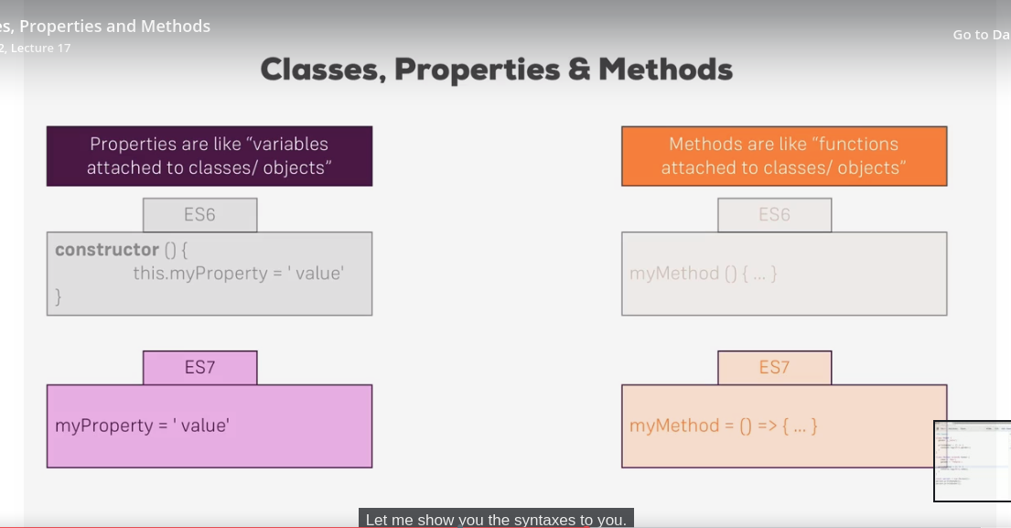
next genn js also offers a different syntax of initializing proeprties and methods. We will use this modern syntax in this course. We do not need to have proeprties inisde constructor fucntion. Behind the scenes this will be transformed to use constuctor fuvntion fucntions.
In methods, we can have syntax where we have proeprty name on left and as value we assign them arrow functions. So w esimply think method as a property which stores a function as a value and thenw e end up with this, my method equla then arrow function. The great advantage of this syntax is since you use arrow functions as a property value, you got no propeblmes with this keyword. This is why we will use this syntax.
ex-
class Human {
gender = 'male';
printGender = () => {
console.log(this.gender);
}
}

class Person extends Human {
name = 'sumeet sood';
printMyName = () => {
console.log(this.name);
}
}

const person = new Person();

person.printMyName();
person.printGender();

herew e removed constructor from both classes. As we removed constructor from Person class, we dnt need to call super in Person.
26)The build WorkFlow
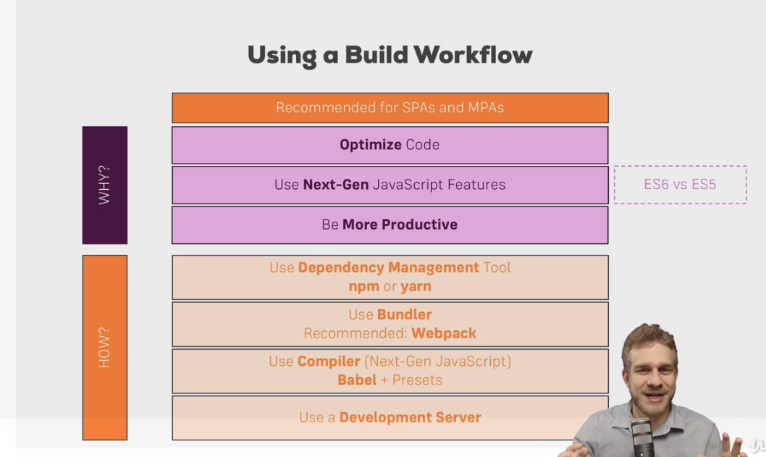
we need more eloborate workflow for real projects. Why we need it and how we achieve it?
We wnt to ship which is as small as possible. Using next genjs is recommended. It is best pratices.
Third point, we wnat to be more productive, this includes next gen javascript features, which allow us to write more condensed code but it also inlcudes things like css auto-prefixing. You might know that css prefixing are a thing to achieve the broadest possible browser support for css fetaures. Noew manually adding these prefixing is quite annoying. So getting them by default is good. Or cosider linting, So a tool that warns you if you write sub-optimal code. It is nice to have . So all thses things should be part of work flow. Now to implement them w ened couple of tools that actually let them run over out code to either warn us bcoz of linting or to compile code that runs on as many browsers as possible, while we a s developer are wiriting very modern code, that on its own wnt run on many broiwsers. So this is why we need complex workflow. Lets see how we can achieve it.
First we need npm. Then we need bundekler we we will be writing modular code, that is code split over multiple files. But in the end we want to make sure that all this code gets bundeled into couple of files in the end when we ship it. Because browsers dnt support split up files.(at least old browsers dnt do). Even ig fbrowser do support multiple files it wnt be optimal to make thousands of requests to these small files. So need to have bundler. We will use webpack which is standard. The cool thing about webpack is it does’nt just bundle files, it allows us to apply couple of other build steops before it does this bundling, for exmaple, the mentioned compilation of next gen javascript, that requires abother tool, babel. We need a compiler that does this javscript compilation, which means translation from the modern features to workarounds that also work on older browsers. We will use babel and presets which can be hooked into webpack configuration. So that they are part of this bundling and optimization process. Fina;;y we need development server to test pur app locally on our machine. Development server is web server but one running on our machine. We could open ahtml file by double clickig on it but this would use file protocol and would not correctly emulate the app running as it runs on web server. Sow e need a web server and we can run one on our machine.
This setup looks like super complex, but there is tool that supports all these. This is created by react community. And is recommneded way of creating react apps. But if you want to see how this works behind the scenes, i also got a module at end of coure where you will build a recat app, a real project strating from scratch.
27)create react app

install this package-
npm install -g create-react-app
to crete project-
create-react-app react-complete-guide
to run it, navigate to folder and run-
npm start
28)Understanding folder structure

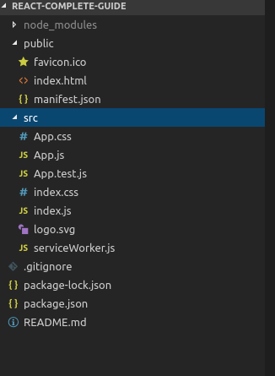

open package.json, here you will see 3 dependencies.
"dependencies": {
"react": "^16.6.3",
"react-dom": "^16.6.3",
"react-scripts": "2.1.1"
}
third dependency is for build workflow. We also have some scripts-
"scripts": {
"start": "react-scripts start",
"build": "react-scripts build",
"test": "react-scripts test",
"eject": "react-scripts eject"
}
we have public folder. Its basically the root folder that gets served in the end, though here it only holds the fils that we can edit. Script files are in source folder. In public folder we have index.html file, this is single html file.we will neevr add more html files in our project. If you are creating mutiplage app with react, you will create mutli react project but you wnt add more html files here. If you want more files here, then you have to setup your own workflow. In this index.html file our script file be injected by workflow. You can edit this file but we wnr write any html code here.in this file we have-
<div id="root"></div>
this is where we will mount our react app. The w ehave manifest.js in public flder. This is because create-react-app gives us progressive web app out of the box. Avery basic one atleat and give sus manifest.josn file where we can define some meta data about our application. Most of time w ewill work in src folder. Here we have app.js
App.js-
import React from 'react';
import ReactDOM from 'react-dom';
import './index.css';
import App from './App';
import * as serviceWorker from './serviceWorker';

ReactDOM.render(<App />, document.getElementById('root'));

// If you want your app to work offline and load faster, you can change
// unregister() to register() below. Note this comes with some pitfalls.
// Learn more about service workers: http://bit.ly/CRA-PWA
serviceWorker.unregister();

as you can see heer we targetting elemnt with id root. We have this in index.html. In id with root. We render compoennt called App. It is imported from app.js file. This is our first compoennt-
app.js-
import React, { Component } from 'react';
import logo from './logo.svg';
import './App.css';

class App extends Component {
render() {
return (
<div className="App">
<header className="App-header">
<img src={logo} className="App-logo" alt="logo" />
<p>
Edit <code>src/App.js</code> and save to reload.
</p>
<a
className="App-link"
href="https://reactjs.org"
target="_blank"
rel="noopener noreferrer"
>
Learn React
</a>
</header>
</div>
);
}
}

export default App;

herew e have jsx. We will dive deepr into what w ewsee here innext lecture. Lets make this file simple-
import React, { Component } from 'react';
import logo from './logo.svg';
import './App.css';

class App extends Component {
render() {
return (
<div className="App">
<h1>Hi I am Recat</h1>
</div>
);
}
}

export default App;

in app.css we have some stylinging that w euse in app.js(we have html in app.js), though i will say that these are notl scoped to this file. These are global stylings. W ecan remove everything from here. Please dnt remove .App styling from here.
We also have index.css file which also applies styles globally and which should be sued fro general setup as here for body of our application. RegisterServiceWorker.js file is related to progressvie web app thatw eget out of the box. It will basically precache our script files. We ndt need to configure anything there. App.test.js is for unit testing.
For most of time we will work in app.js, or other compoennts that we will create in our app.
29)Undetsnading Component basics
our first compoent is app.js-
import React, { Component } from 'react';
import logo from './logo.svg';
import './App.css';

class App extends Component {
render() {
return (
<div className="App">
<h1>Hi I am Recat</h1>
</div>
);
}
}

export default App;

it is used in index.js file where we replace element with id root, with this component.
Index.js-
ReactDOM.render(<App />, document.getElementById('root'));
we can render normal html here like
ReactDOM.render(<h1>Sumeet</h1>, document.getElementById('root'));
vv-
but we want to render our react compoennt here.
Now we can use mutiple RecatDOM.render calls, to render all html code you want. But this is not how we create our react app. Typically we render our root compoennt, App Component, but you can renmae it whatever you want. In this root compoennt, you can then nest all other compoennts your app might need.
Now lets go to component.here we say one of 2 ways of defining recat components-
import React, { Component } from 'react';
import logo from './logo.svg';
import './App.css';

class App extends Component {
render() {
return (
<div className="App">
<h1>Hi I am react App</h1>
</div>
);
}
}

export default App;

here we import 2 things, React and Component. Recat is responsoible or required for rendering anything, anything to DOM. We always need to import that in a file where we define a component.

it has render method which returns html which can rendered .it needs to have this method because react will call this method to render anything on screen. This is most importnat job that every react component has to do. You can do other things in compoent like lsiten to events, reach out to internet, but in the end you must return html.
Now you might find some components has extension of jsx, this is because in render method we return jsx(wes aid it is html but is not), it might look like html but it is jsx, so javacsript, looking little different. It is some synactical sugar basically invented by react team and we can write it in our js file because of build flow. It will basically automatically transpile it to to valid js in the end. It is not connected to to file extension you are using, it works in jsx and js files and the convention now a days is to use .js files which is why here we also use js files. And it simply is a code or syntax we can use to write html in quation marks whilst in the end not writing it. Confusing? Let me show what it is compiled too in next lecture.
30)Understanding JSX
lets comment out our jsx code then we call method on react. Actually in the end JSX code is compiled to it, this is actually reason, why we need to import React here. So code we commented out will be compiled to what we wrote above.
Now createElement takes infine amount of argument, but it needs atleast 3. first one is elemnt that wew ant to render to DOM. This can be any html element lement like div or t can be your own component if you have one avalible here, second argument is cofiguration , this is optionaland we will pass null for now. Third argument is any amount of childern and we could have multiple arguments separated by ‘,’. childern means what is nested inside this div. Now we want to nest h1 element. Lets do this-
import React, { Component } from 'react';
import logo from './logo.svg';
import './App.css';

class App extends Component {
render() {
// return (
// <div className="App">
// <h1>Hi I am react App</h1>
// </div>
// );
return React.createElement('div', null, 'h1', 'Hi, I am React App!!!!');
}
}

export default App;

now h1 is just identified as text. This is default bevaiour.
Html generated is-
<div>
h1
Hi, I am react
</div>

so h1 here is interperated as text not h1 element. To ahve another html element, we need to again call the React.createEleemnt like this-
return React.createElement('div', null, React.createElement('h1', null,'Does this work now'));
now we got what we want. Now lets assign class. In jsx syntax, we used className instead of class, we will come back to it later. Now this is important now cod that we wrote now with createElemnt is eaxctly same as what we wrote with jsx syntax. Jsx code will get complied to what w ejust wrote now. This is reason we have to import React in compoennt, even if we were not suing it when we sued jsx syntax. Behind the scens it is used once jsx is compiled. W euse jsx approch because second approach will get cumbersome. So this is importnat to understand jsx might look like html but it is not. It is js in end it gets compiled to what we just wrote.

31)JSX restrictions

